Camden breaching data protection and putting the public at risk
Why are people's personal details being given to strip club operators when the ICO has already twice told Camden this is unlawful and after a number of people were sent threatening legal letters by a strip club at the last round of licensing hearings because of this?
Why is the council still acting unlawfully on this and is itself providing a cause of considerable concern for public safety? This is particularly so, given the track record of crime and disorder and prostitution linked to the strip clubs who you are giving people’s personal details to: www.notbuyingit.org.uk/strip-publications#Camden
FOR THIS REASON I HAVE BEEN FORCED TO USE THE CONTACT DETAILS OF MY REPRESENTATIVE, NOT BUYING IT
PLEASE ENSURE NO INFORMATION ABOUT ME (MY NAME, EMAIL) IS GIVEN TO THE STRIP CLUB OPERATOR OR MADE PUBLIC

Irregular Licensing procedures
What happened to this club’s licensing hearing in 2020 which appeared to be only partially carried out? Why weren't all objections from last year carried over to this year? At very least everyone who objected last year should have been told they have to re-object this year – why weren’t they?
At the last licensing hearing for this chain, Not Buying It, exposed that the applicant is unfit due to the long list of breaches at the Secrets chain, particularly Secrets Eversholt Rd whilst trading as Secrets (it is now trading as ‘Sophisticats’ although still registered with Companies House with a Secrets name).

UNFIT LICENSE HOLDER
At this club’s last licensing hearing the applicant appeared to lie to the council – this is unlawful. This was raised with the council but ignored. He stated there ‘have never been any serious incidences’ at any of his clubs. At a second hearing he then stated he had looked through all relevant minutes and still found no breaches.
However, the Secrets Eversholt branch had had numerous police and trading standard reports of serious incidences. This was in report packs and in minutes of Council meetings. It included the police working closely with the applicant ‘to resolve issues’.
How could the applicant have been ‘unaware of any incidences’?
These are listed below, further, I would remind the council that its own policy states that it must consider the history not only of the strip club in question but of the entire chain.
With particular reference to Parker St Secrets, the police called for the license to be revoked at its last licensing hearing:

Camden Secrets Chain
Summary of Incidences at the 3 Camden Secrets clubs
Sexual Contact [2013] Chain fails in court to allow dancers to touch themselves sexually
Debt [2018] : Chain £4.7 million in debt
Tax Payers Money Suppl Agenda p9 [2020]: Chain seeks £90,000 from Late Night Levy
Secrets [2019]: History of incidences not allowed to be included at 2019 licensing hearings
Secrets [2019]: ‘Never been any serious incidences at any of my clubs’ Owner at Licensing Hearing
Secrets [2019] Not Buying It raises section 21 complaint ‘applicant lied to council’

Camden Secrets Eversholt Rd
Sexual contact, assaults: Lap dancer [2008]
Sexual Touching [2011] Touching even when performing for women: Evening Standard
Assault p148 [2016] GBH. One customer Assaults Another: Police Report
Council Incompetence p2 Council unaware of 2016 assault at club’s licensing hearing
Fraud App. 10 [2016] Financial Fraud vs intoxicated customer: Trading Standards
Fraud App. 10 [2017] Financial Fraud vs intoxicated customer: Trading Standards
GBH App. 10 [Jan 2017] GBH vs lap dancer, club do not inform police: Police
Assault p 149 [May 2017] Drunk customer complains of assault, police not called: Police
Assault p149 [Nov 2017] Drunk customer assaults waiter, security do nothing: Police Report
Fraud App. 10 [2018] Financial Fraud: Trading Standards
Sexual Contact App.9 [2018] Rampant Sexual Contact, no club intervention: CCTV/Police
Sexual Contact App. 9 [2019] Rampant Sexual Contact, no club intervention: CCTV/Police

License transferred to Sophisticats, which trades as Secrets Camden Ltd:
Fraud [2019] 13 reports financial fraud: Trading Standards
Sophisticats [2019]: Workers/Supporters defend club
Owner [2019]: ‘Many punters spend £50,000 in one night’
Club provides mental health therapy to lap dancers App. 16 [2019]
Mette, survivor: ‘Don’t put clubs in charge of dancer ‘welfare”

Camden Secrets Gray’s Inn Rd
Touting [2017] Club breaches license conditions by Flyering (clubs may not tout for business)
Council [2020, 2021]: Ignores evidence of abuse in chain at club licensing hearing

Camden Secrets Parker St
Soliciting App. 10 [2017] Soliciting, unsafe for women: Local Residents
Pimps [2018] Numerous Pimps pose as cabbies outside: Resident
Sexual Contact p 251 [2019] Club given ‘Yellow Card’: Council Inspection
‘No breaches’ [2019] No sexual contact’ observed on Pre-Announced Council Inspection
Pimps [Feb 2020] p285 Numerous ‘sex touts’ in vicinity: Police Report
Touting [Feb 2020] p284 Unlawful touting by club: Police Report
Police ‘Revoke License’ p 286 [2020] Police call for license to be revoked: Police Report

UNFIT LICENSING HEARINGS:
This also exposes serious flaws in the licensing hearings themselves as the committee were totally unaware of these serious incidences (which included GBH and financial fraud). They also refused to consider the information we had collated from their own reports on these incidences, even though the hearing was deferred and there was amble opportunity for both the committee and applicant to consider this (in fact the applicant took it upon himself to do just that but still appeared to find nothing in minutes relating to wrong doing at his club/clubs).

UNFIT LICENSE HOLDER/ EXTREME LEVELS OF DEBT/ PREVENTION OF CRIME & DISORDER
The license holder also appears to carry extreme levels of debts, amounting to £millions, in the many holding accounts for the various strip chains he operates: Debt [2018] : Chain £4.7 million in debt:
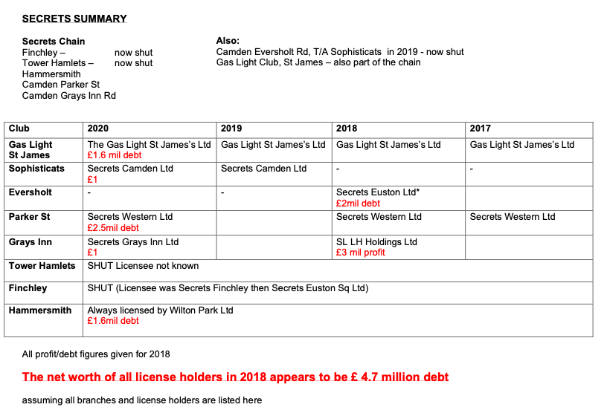
BREACH OF EQUALITY LAW
The council is charged with seeking to ‘eliminate harassment, discrimination and victimisation of women’ and ‘to foster good relations between the sexes’ in all its policy and licensing decisions. This includes women in the clubs, in their vicinity and in wider society. You cannot possibly do this and license strip clubs – particularly clubs like Secrets with abusive operations inside and pimps documented for years outside.
Refuse on grounds of inappropriate locality
Your objection process is further unfit and again potentially unlawful as you claim SEV licenses can only be refused on very limited (serious and substantial) grounds such as crime and disorder, public safety and child protection
This is not correct, the council may also refuse on the grounds of inappropriate locality.
Further, refusal on the grounds of locality effectively CANNOT be challenged in court- whatsmore no change in locality or any other material change or evidence of harm or anything else is required in order to refuse on these grounds. Given that your own policy states there is NOWHERE in the borough appropriate for a strip club, I object first and foremost on the grounds of inappropriate locality.

